

Transparency Quarterly Report
October 2024 – December 2024
Office of the Police and Crime Commissioner

This report is to inform the reader of the Transparency/Governance obligations of the Office of the Police and Crime Commissioner (OPCC). The OPCC will publish this information on a quarterly basis, to ensure that the public can review the functions of the OPCC. The areas of focus for this report are:
- Professional Standards Department (PSD) Dip Sampling
- Customer Services/Lower Dissatisfaction Dip Sampling
- Chief Constable Complaints
- Reviews
- Independent Custody Visitors (ICVs)
- Legally Qualified Chairs (LQCs)
- Freedom of Information / Subject Access Requests
- Trends/Patterns received by the OPCC.

Dip Sampling – Schedule 3 complaints – Professional Standards Department

The purpose of the OPCC Dip Sampling Schedule 3 complaints it that it is a critical function to the reputation of Bedfordshire Police that the public has confidence in the complaints system. To this end, both the Chief Constable and the Police and Crime Commissioner have arranged for ‘dip sampling’ to be undertaken of complaints. On a monthly basis, the OPCC will request categories of complaints from the Professional Standards Department and when the files have been received will review them in full.
The categories of complaint are:

Complaint Categories & Subcategories

A | Delivery of Duties and Service
A1 Police action following contact / A2 Decisions / A3 Information / A4 General level of service.

B | Police powers, policies, and procedures
B1 Stops, & stop & search / B2 Searches of premises & seizure of property / B3 Power to arrest & detain /

B4 Use of force / B5 Detention in police custody / B6 Bail, identification, and interview procedures /

B7 Evidential procedures / B8 Out of Court disposals / B9 Other policies and procedures

C | Handling of or damage to property / premises
D | Access and / or disclosure of information
D1 Use of police systems / D2 Disclosure of information / D3 Handling of information /

D4 Accessing and handling of information from other sources.

E | Use of Police Vehicles
F | Discriminatory behaviour
F1 Age / F2 Disability / F3 Gender Reassignment / F4 Pregnancy & Maternity / F5 Marriage & Civil Partnership /

F6 Race / F7 Religion or Belief / F8 Sex / F9 Sexual Orientation / F10 Other

G | Abuse of Position / Corruption
G1 Organisational corruption / G2 Abuse of position for sexual purpose /

G3 Abuse of position for the purpose of pursuing an inappropriate emotional relationship / G4 Abuse of position for financial purpose / G5 Obstruction of justice / G6 Abuse of position for other purpose

H | Individual Behaviours
H1 Impolite language or tone / H2 Impolite and intolerant actions / H3 Unprofessional attitude and disrespect

H4 Lack of fairness and impartiality / H5 Overbearing or harassing behaviours

J | Sexual Conduct
K | Discreditable Conduct
L | Other

The OPCC will consider such aspects when completing the Dip Sampling:
- Timescales for completion of investigations
- Learning Identified
- Were all allegations covered fully and appropriately?
- Satisfaction
- Was Body Worn Video (BWV) used and was it useful to the complaint?
- Other aspects are considered throughout the process.
The process relates only to the Dip Sampling of closed complaints cases and does not cover either the duty to oversee ongoing complaints or the new wider power of direction of the handling of complaints against the police.
The purpose of Dip Sampling is not to interfere with the review process and decisions made by the Relevant Review Body can only be overturned by the courts through the Judicial Review Process.

Q4 – PSD Dip Sample

Bedfordshire OPCC dip sampled 12 complaints in October 2024. Within the 12 complaints, 38 allegations were covered.
Bedfordshire OPCC dip sampled 20 complaints in November 2024. Within the 20 complaints, 97 allegations were covered.
Bedfordshire OPCC dip sampled 15 complaints in December 2024. Within the 15 complaints, 91 allegations were covered.
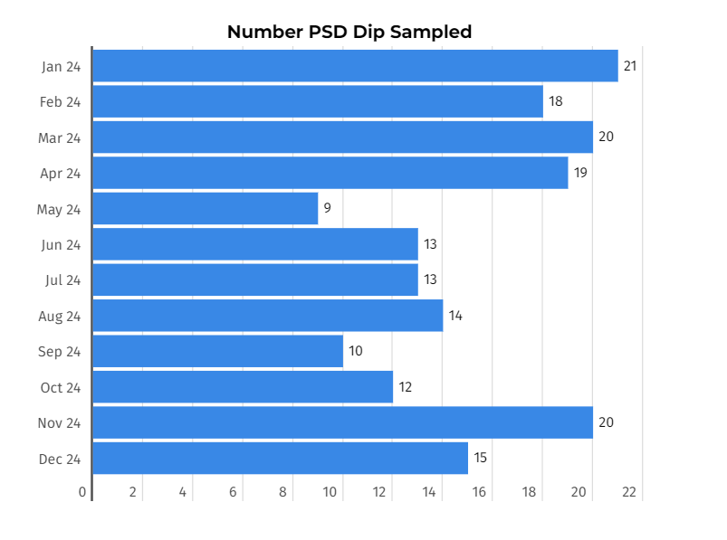
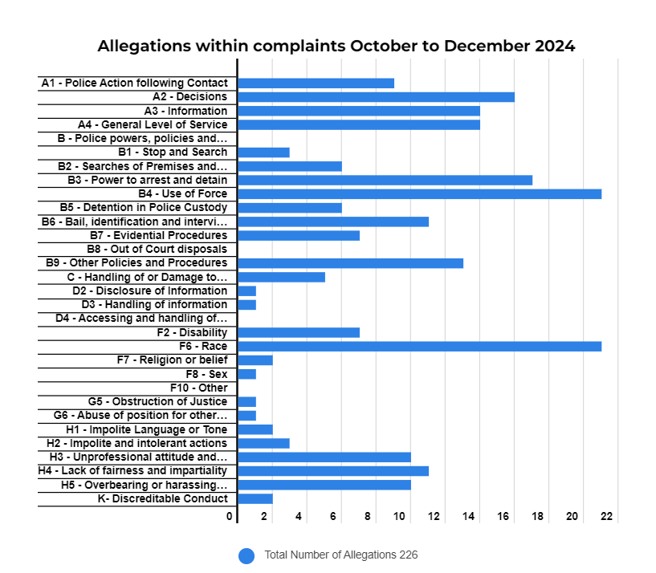
Bedfordshire OPCC believe that all PSD complaints dip sampled have been dealt with in a reasonable and proportionate manner.
Clarification or further information was required on 12 of the 47 PSD dip sampled. Overall, on average those dip sampled PSD took 3 months (which is a vast improvement from the 5 months of the previous quarter) to complete the investigation and the average time to acknowledge the complaint was 47 days compared to the previous quarter of 44 days. This increase was due to two particularly long lack of response.
43% of those sampled found Service was not/partially not acceptable for all allegations.
The top three categories respectively have been:
- Race
- Use of Force
- Power to arrest and detain
These supersede Use of Force, Race and General Levels of service from the previous quarter.
The Office of the Police and Crime Commissioner’s Office (OPCC) agreed with any learning identified within the complaint reports and identified additional points including the need to explain acronyms in correspondence to the public.

CRT/Lower Dissatisfaction – Dip Sample
The Governance and Transparency team conduct monthly dip sampling of lower dissatisfaction complaints and hold a monthly meeting with the Customer Support Management team to discuss findings, to ensure feedback is given and fed into future learning.
The Customer Support and dissatisfaction dip sampling commenced in August 2021 and is completed monthly via access to the police force framework.
The OPCC will consider such aspects when completing the Dip Sampling:
- Complaint
- Allegations
- Victims Code of Practice
- Recommendations or actions
- Timescales
The process relates only to the Dip Sampling of closed complaints cases and does not cover those that remain an enquiry.
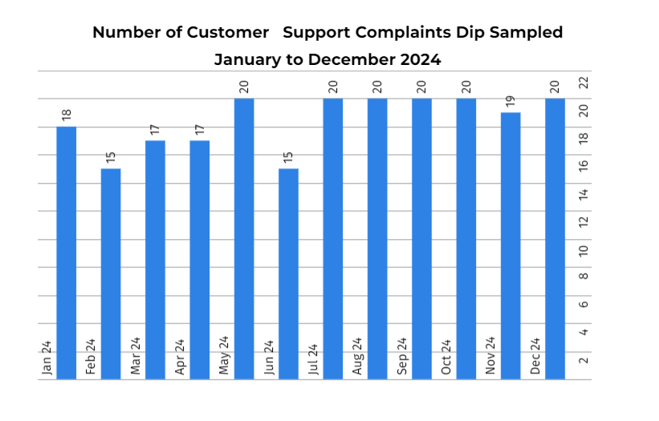

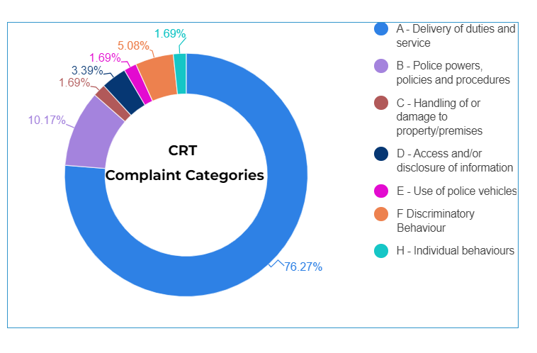

Chief Constable Complaints
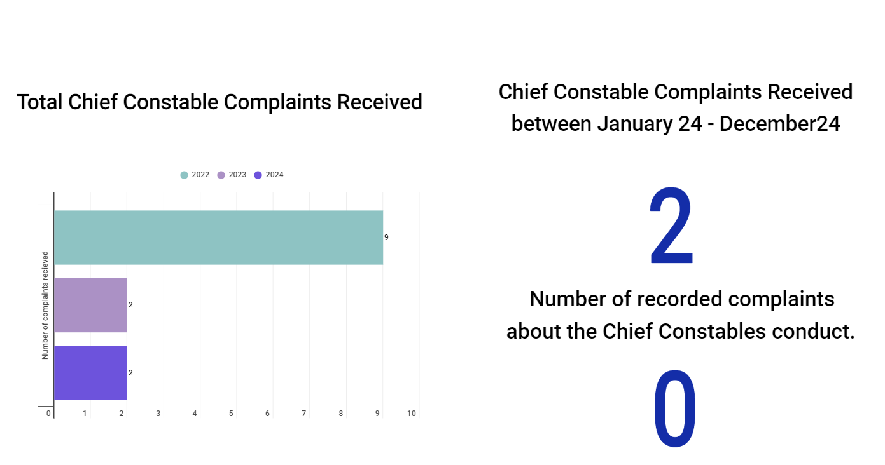
No Chief Constable complaints have been recorded within the third quarter – October 2024 to December 2024.
Complainants have contacted the OPCC regarding matters which they deemed to be a complaint against the Chief Constable, however if the complaint is not about the Chief Constables conduct directly, it is not a complaint against the Chief Constable. Complainants believe as the Chief Constable has overall responsibility for the Force, they believe he is accountable, and complaints can be made against him. However, if the OPCC reviews the allegations made against the Chief Constable Trevor Rodenhurst, and on immediate review of your complaint, the complaint is not regarding the conduct of the Chief Constable and that the Chief Constable has not had any personal involvement into the case and delegates such responsibilities to others within the organisation, a complaint will not be recorded.
The IOPC statutory guidance states ‘A.7 There will be times where a complaint names the chief officer or acting chief officer, but the complaint is about something where authority has been delegated to another officer or staff member within the force. Where the local policing body receives a complaint for which is it is not the appropriate authority, they must forward the complaint to the appropriate authority. Therefore, where it is immediately clear that the chief officer or acting chief officer has not been involved, the local policing body must take the steps outlined in paragraphs 6.5 – 6.7. They should explain the reasons for this to the complainant.’
So, all complaints of this nature are forwarded to the Customer Services team of Bedfordshire Police to review and allocate to individuals within the Force.

Reviews
From the 1st of February 2020, the Office of the Police and Crime Commissioner (OPCC) is the relevant review body in most cases, apart from those complaints or conduct matters listed below which the IOPC are responsible for reviewing where they relate to:
- Any incident or circumstance in or in consequence of which a person has died or suffered serious injury.
- A serious sexual assault or offence
- Serious corruption
- Criminal offence or behaviour which is liable to lead to disciplinary proceedings.
If a request to review is submitted to either the IOPC or the OPCC and they are not the correct review body, then they will forward it to the correct review body and notify the complainant that this has happened.

What a review means
A review offers the opportunity to consider whether the complaint outcome is reasonable and proportionate but not the handling of the incident leading to the complaint. Each review will be considered on a case-by-case basis. If the reviewer concludes that the outcome was not reasonable and proportionate, the review should be upheld i.e. the service provided by the police was not acceptable the OPCC will, where appropriate, make recommendation to the Chief Constable of Bedfordshire Police.

Requesting a complaint review
Complainants will have been advised by PSD in their complaint outcome letter if they have the right of review and who is the appropriate review body (either the OPCC or IOPC). The review can only be against the outcome of a formal complaint, i.e., a complaint that has been recorded under the legislation. The right of review does not apply to an informal complaint i.e., one that has not been recorded.
The timeframe for requesting a review is 28 days from the date of the letter concluding the complaint.
Before a complaint can be reviewed by the OPCC it must be formally recorded by Bedfordshire Police’s Professional Standards Department (PSD) under Schedule 3 of the Police Reform Act 2002.
This is different to having an expression of dissatisfaction dealt with/logged by the Force through their Customer Support team and which has not been recorded under Schedule 3.
Complaints recorded under Schedule 3 will be handled and investigated by the Force or the IOPC (depending on the severity of the allegation).
The Police and Crime Commissioner nor the OPCC can get involved at this stage or investigate the original incident leading to the complaint being made as this could potentially compromise any future request by the complainant to review.
Bedfordshire Police having concluded their investigation of the complaint, will inform the complainant of the outcome, including information about the right to apply for a review, who is the appropriate review body (either the OPCC or IOPC).
Should the complainant wish to request a review, then an application for a review must be in writing and state the following:
- the details of the complaint.
- the date on which the complaint was made.
- the name of the force or local policing body whose decision is the subject of the application.
- the date on which the complainant was provided with the details about their right of review at the conclusion of the investigation or other handling of their complaint.
- the complaint reference number on the outcome letter from PSD.
Due to the changes in the Specified information Order – the OPCC needs to ensure that review information is readily available.
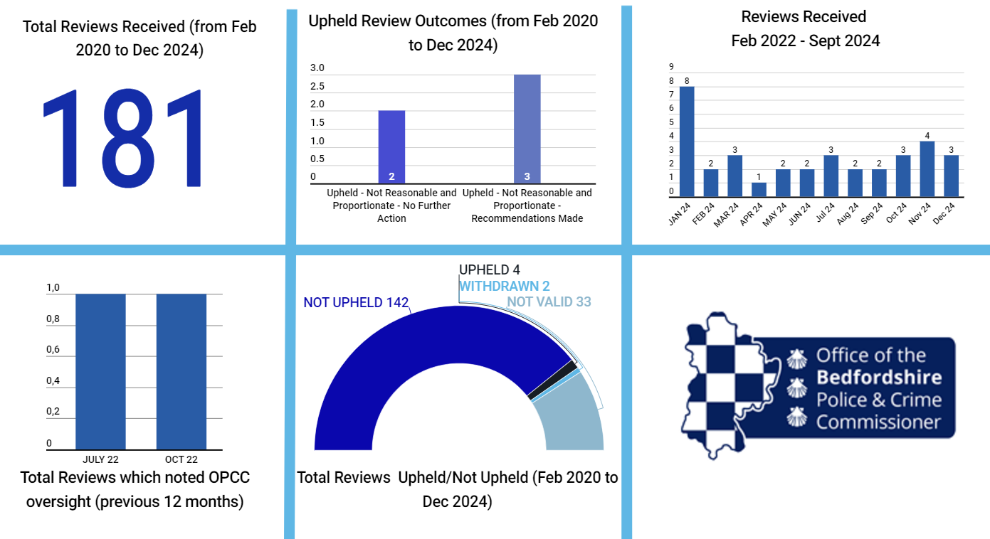

Independent Custody Visitors

Under the Police Reform Act 2002, as amended by the Police Reform & Social Responsibility Act 2011, the Local Policing Body has a statutory duty to establish and maintain an Independent Custody Visiting Scheme, which involves volunteer members of the public visiting police stations to check and report on the treatment of detainees, the conditions in which they are held and that their rights and entitlements are being observed. The scheme offers protection and confidentiality to detainees, the police and provides reassurance to the wider community.
There are two dedicated Police Custody Suites in Bedfordshire. These are located in Kempston with 22 cells and Luton with 21 cells.
The purpose of Independent Custody Visiting is to provide assurance that detainees in Bedfordshire Police Custody are:
1. Treated fairly and in accordance with the Police and Criminal Evidence Act 1984 (PACE) and associated codes of practice
2. That the conditions detainees are kept in are clean and safe and any matters of concern are recorded and dealt with effectively.
3. That the rights and entitlements of detainees in Bedfordshire Police Custody are observed and adhered to.
Independent Custody Visitors are members of the local community who, working in pairs, call at Police Stations unannounced at any time. With agreement, the visitors can speak to detainees about their treatment or conditions and take up any issues of concern with custody staff. A short report of their findings is made prior to leaving the station. Their work provides the PCC (and in turn the local community) with assurance that anyone arrested by the police and held in custody is treated fairly and has access to appropriate facilities.
Bedfordshire ICV Scheme has 30 ICVs as of December 2024.
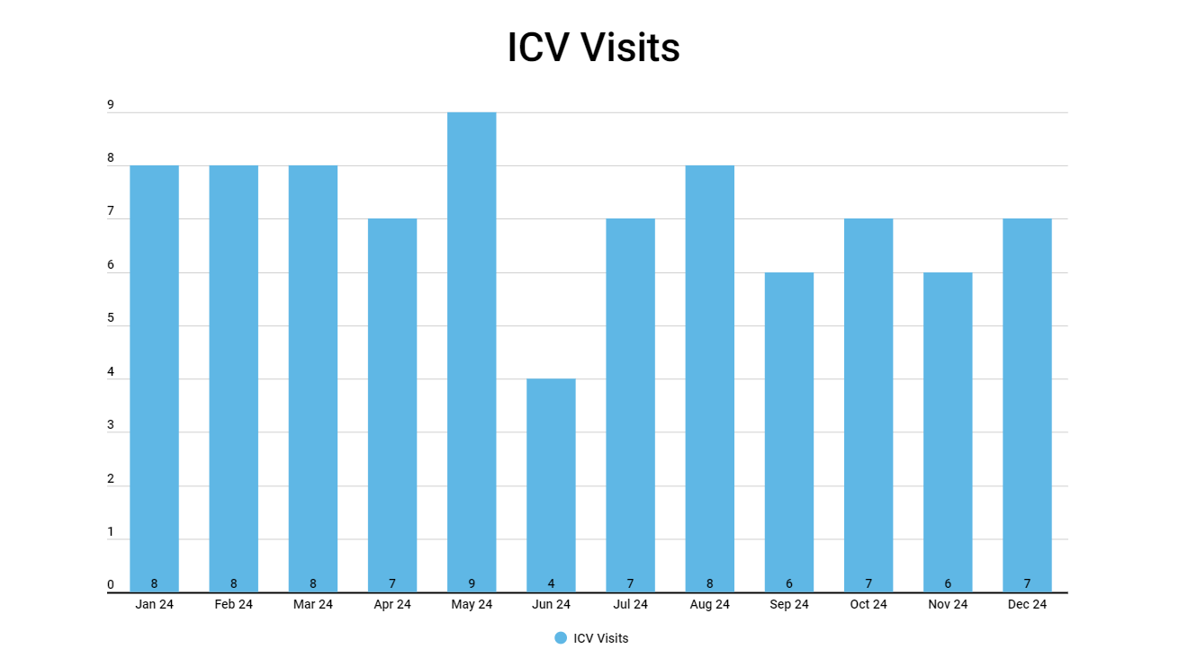

Points to note that have been raised during the visits:
- Drainage issue within Luton but this will be rectified when the refurbishment happens Jan 2025
- Out of date cereal packs but this has been rectified.
- Religious materials not stored correctly in Kempston.
- Walls need to be touched up within Kempston Custody showing signs of wear and tear.

Good practice:
- ICVs have noted on several occasions how helpful staff are, especially when Custody is busy. Staff are reported to be caring, professional and informative.
Note: Kempston custody will be operating at full capacity as Luton custody closes for refurbishment. Any additional spaces are being provided by Hatfield custody.

Legally Qualified Chairs
Following a public consultation led by the Home Secretary in the autumn of 2014, changes were made to the police disciplinary system for the purposes of more transparency, independence, and justice. These included holding police misconduct hearings in public (from May 2015).
The Police Misconduct Hearing Panel is likely to be convened to hear allegations of serious cases of misconduct by police officers. The maximum outcome at this hearing would be dismissal from the police service without notice. Cases would include for example, allegations of criminal acts, serious road traffic matters such as drink/driving and other serious breaches of the standards of professional behaviour expected of police officers such as neglect of duty.
Misconduct Hearings could also be convened to consider the final stages of action under performance regulations, where police officers can be dismissed for unsatisfactory performance or attendance.
The Misconduct Hearing Panels will hear cases governed by the Police (Conduct) Regulations 2020. For the purposes of this Handbook, all references will be to the 2020 regulations. (It should be noted that cases where investigations commenced prior to 1st February 2020 will be heard under the Police (Conduct) Regulations 2012 (amended by Police (Conduct) (Amendment) Regulations 2014 and 2015). Should this be the case an LQC will be advised of the relevant regulations to be applied.)
For misconduct hearings commenced after 7 May 2024, panels will consist of three persons: The Chair (Chief Constable or delegated senior person)2 , an IPM with relevant experience, and a second IPM. There is no difference between the two IPMs in terms of responsibility or payments. There is also the appointment of a non-decision making Legally Qualified Person (LQP), sometimes referred to as a Legally Qualified Advisor (LQA) to provide guidance to the panel.
For those hearings that were formed prior to 7 May 2024, until the end of the transition period, they will consist of a Legally Qualified Chair (LQC), a police officer of at least Superintendent Rank and an IPM.
In relation to a Police Appeals Tribunal, the panel when formed, consists of a Chair drawn from a list appointed by the Home Secretary, a senior officer and above, and an
The Police (Conduct) (Amendment) Regulations 2024, Regulation 3 (4B) (a) a senior officer (ACC and above); (b) a former senior officer, who last served as a senior officer no more than five years, a police staff member who, in the opinion of the chief officer of police, is of at least a similar level of seniority to a senior officer.
The Hearing Panels consist of three persons: The Legally Qualified Chair (LQC), a police officer of the rank of superintendent or above, and an independent member (IM).
The OPCC is the authority to appoint LQCs and IMs and in line with the transparency pledge made by the PCC the OPCC the figures below show the numbers that have been appointed.
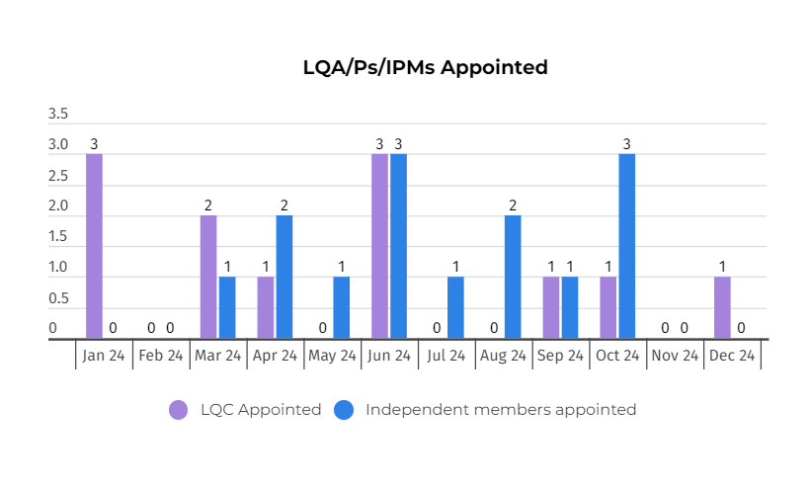

Freedom of Information/Subject Access Requests
The OPCC have received several Freedom of Information and Subject Access Requests which were meant to be for the Force. The Governance and Transparency team respond to all requests for Force information, advising that we do not hold the information and that it must be requested from the Force directly, as well as providing the contact information.
The OPCC has a dedicated website page in which it clearly explains that the OPCC does not hold and cannot access Force data/information.
Consideration needs to be given regarding communication to the public as to the process on where information is requested from.

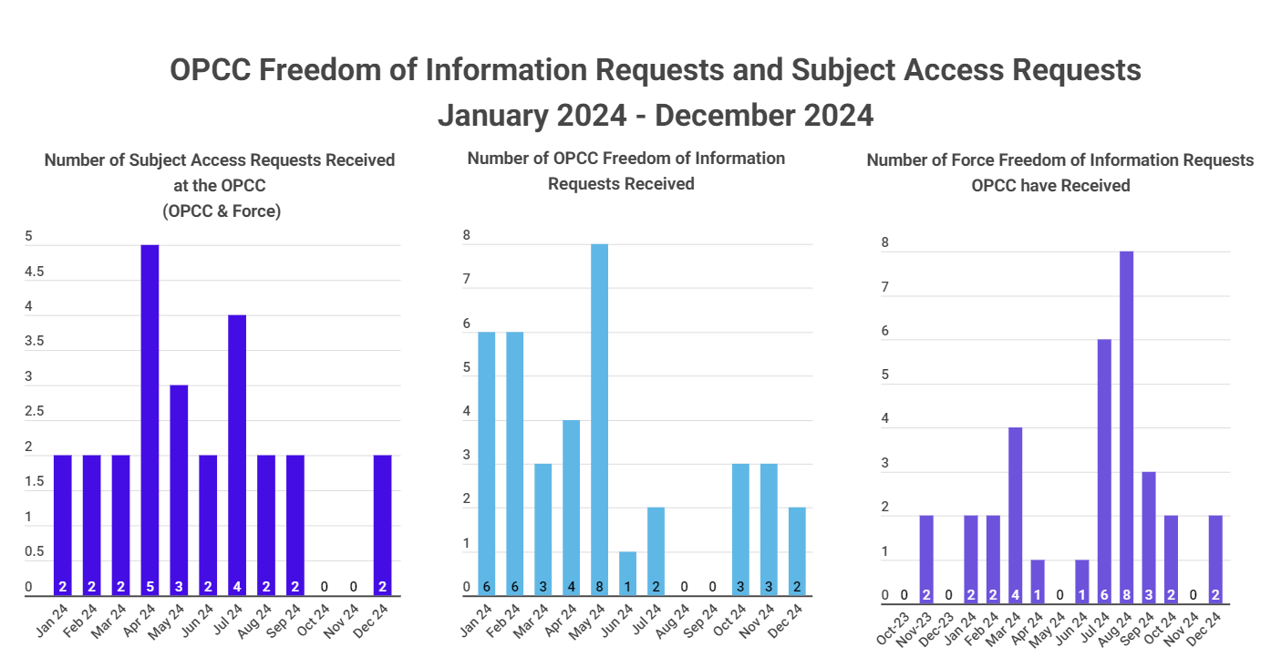

Trends/Patterns
The OPCC had a total of 222 pieces of correspondence which were logged in Quarter 3 Oct to Dec 2024 which is a 19% (47) decrease from the previous quarter.
There have been overarching themes within the correspondence and a breakdown of most frequent contact trends/themes is shown below (excluding SAR/FOI/general correspondence requests). 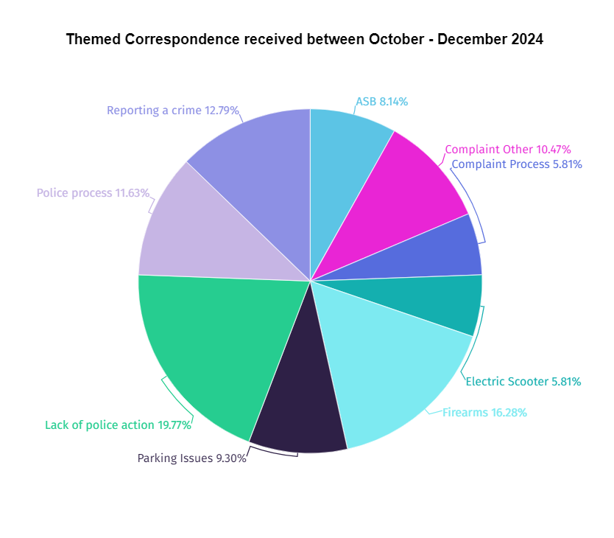
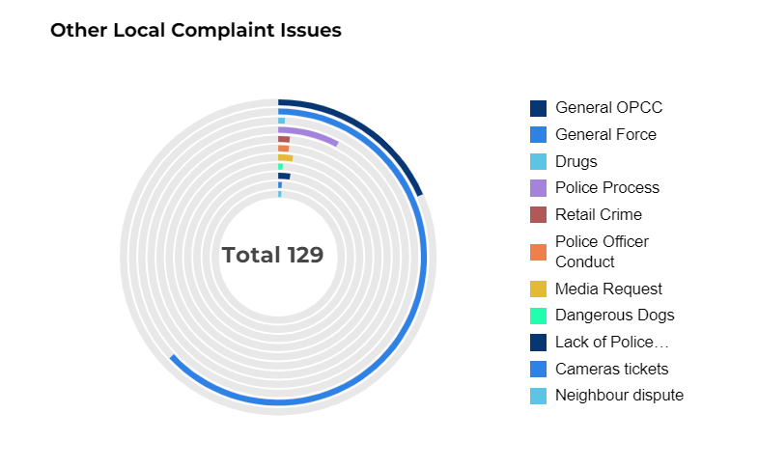

All complaints are forwarded to Bedfordshire Police Customer Support Team. The role of the Customer Support Team is to initially handle the complaint. They will be in contact with the complainant at the earliest opportunity where they will gather information in regard to the complaint to fully understand it.

The Policing and Crime Act 2017: changes to the police complaints system
Legislation changed in February 2020 to ensure that matters can be dealt with at the most appropriate level, supporting both the efficiency and fairness of the complaints system. There is still provision for the most serious matters to be investigated independently. Below that level there are a wide range of complaints that are most appropriately dealt with by the police themselves. The changes allow for certain types of complaints to be resolved outside the requirements of Schedule 3 to the Police Reform Act 2002, while those that have been recorded may be handled reasonably and proportionately otherwise than by investigation, by investigation, or, in some circumstances, no further action may be taken. This allows for the police to quickly learn from, and make improvements based on, the complaints they handle.
All local policing bodies have certain duties in relation to the handling of complaints. They can also choose to take on responsibility for certain additional functions that would otherwise sit with the chief officer:
- Model 1 (mandatory): all local policing bodies have responsibility for carrying out reviews where they are the relevant review body.
- Model 2 (optional): in addition to the responsibilities under model 1, a local policing body can choose to assume responsibility for making initial contact with complainants, handling complaints outside of Schedule 3 to the Police Reform Act 2002 and recording complaints.
- Model 3 (optional): a local policing body that has adopted model 2 can additionally choose to assume responsibility for keeping complainants and interested persons properly informed of the progress of the handling and outcome of their complaint.

Local policing bodies do not become the appropriate authority for the complaint under any of the above models. Rather, in the case of models 2 and 3, they perform some of the functions that the chief officer would otherwise carry out as the appropriate authority.
Bedfordshire’s OPCC has adopted Model 1, which is the mandatory level.
All complaints functions will remain within the Police Force (except for complaints made against the Chief Constable which are reviewed by the OPCC). The Force has set up a Customer Support Team (CST) which is looking after the initial complaints function. No complaints will now be received directly to the Professional Standards Department (PSD), they will be triaged by the CST on the severity of the complaint.
If complaints meet the threshold for severity, they will be passed on to the PSD for investigation. However, if they are lower-level complaints which can be dealt with outside of the schedule 3 complaints legislation, the CST will deal with and log on to the CRT Database for complaints.
The Office of the Police and Crime Commissioner (OPCC) is unable to investigate complaints against Bedfordshire Police or individual members of staff. This falls to the operational management of Bedfordshire Police. Individual complaints should, therefore, be directed in the first instance to Bedfordshire Police.
Bedfordshire Police deal with all complaints against police officers below the rank of Chief Constable, all police staff, and the Special Constabulary. For minor matters that can be resolved quickly and simply, a supervisor can usually deal with your complaint. More serious matters, however, are referred to the Professional Standards Department, who will oversee the process. Some matters, due to their nature or seriousness, are referred to the Independent Office of Police Conduct (IOPC).
There is a reduction of correspondence being received from last year, however the OPCC believe this is due to the OPCC message being received that we are unable to influence operational policing decisions or investigate any complaints, except for the Chief Constable.

Guidance on Outcomes in Police Misconduct Proceedings 2022, 2.3 Police Misconduct Proceedings https://assets.production.copweb.aws.college.police.uk/s3fs-public/2022-08/Guidance-on-outcomes-inpolice-misconduct-proceedings.pdf

