Declaration of interests

To safeguard the integrity of the Police and Crime Commissioner (PCC), it is essential that any declarations of interest are publicly made to ensure openness and transparency and to safeguard the PCC against any potential challenge.

All declarations should be declared and reviewed annually as a matter of course. The PCC can update the declarations at any time should his or her circumstances change.

The declarations will be held on a register in the Office of the Police and Crime Commissioner (OPCC) and will be made available through the OPCC website.

I, (Full Name)
Police and Crime Commissioner John Tizard

- Note: In the notice below reference to your spouse or partner means your spouse or civil partner; or a person with whom you are living as husband or wife; or a person with whom you are living as if you are civil partners.

Subject | Disclosable Interests | Declaration (You) | Declaration (Spouse/Partner)
Employment, office, trade, profession or vocation. | Any employment, office, trade, profession or vocation carried on for profit or gain. | Director - John Tizard Ltd  (company now dormant) | Director - John Tizard Ltd
Sponsorship | Include details of any payment or provision of any other financial benefit (other than from the elected local policing body/OPCC) made or provided within the relevant period in respect of any expenses incurred in carrying out duties as a member, or towards the election expenses. This includes any payment or financial benefit from a trade union within the meaning of the Trade Union and Labour  Relations (Consolidation) Act 1992 (a) | Election sponsored by Labour Party and  Co-operative Party | N/A
Contracts | Include details of any contract which is made between the  relevant person (or body in which the relevant person has | N/A | N/A

 | a beneficial interest) and the elected local policing body/OPCC – (a) under which goods or services are to be provided or works are to be executed; and (b) which has not been fully discharged.
Land | Include details of any beneficial interest in land which is within the elected local policing body/OPCC Force area | Home Address - Private | Home Address - Private
Licenses | Include details of any licence (alone or jointly with  others) to occupy land in the elected local policing body/OPCC Force area | N/A | N/A
Corporate Tenancies | Include details of any tenancy where to your  knowledge – (a) the landlord is the elected local policing body/OPCC; and (b)  the tenant is a body in which the relevant person has  a beneficial interest | N/A | N/A
Securities | Include details of any beneficial interest in securities of a body where – (a) the body (to your knowledge) has a place of business or land in the elected local policing body/OPCC Force area; and  (b) either – the total nominal value of securities exceeds  £25,000 or 1/100th of the total issued share capital of that body; or if the share capital of that body is of more than one class, the total nominal value of the shares of any one class in which the relevant person has a beneficial interest exceeds 1/100th of the total issued share capital of that class | N/A | N/A

Membership of the following bodies | (include Political Parties, Social Groups, Freemasonry etc.) | Labour Party  Co-operative Party  Unite  Fabian Society  Liberty  Association of Police and Crime Commissioners | Labour Party  WEA
Stakeholder Organisation | Any other role within a stakeholder organisation (e.g. trustee etc.) | Director of Blue Light Commercial March 2025 (non remunerated)  Trustee of Making Me - 2023  APCC Joint Lead for Performance, and Data and Ethics  Home Office Police performance board  Home Office/HMICFRS – Police Performance Monitoring Group  Home Office Police Data Reform board  NPCC Audit and Assurance Board  HMICFRS External Reference Group  Home Office/NPCC Steering Group – Police.AI  Vice Chair CT Collaboration Board  ERSOU Board  Chair of Blue Light Commercial Ltd (BLC) | N/A

Signed: 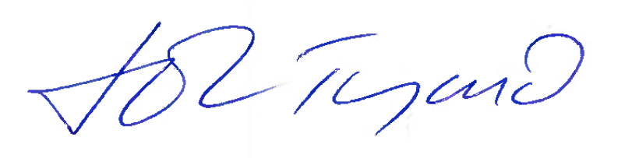

Date: 30/06/2026

