ICV Annual Report
April 2020 – March 2021
Bedfordshire Office of the Police and Crime Commissioner

Bedfordshire Independent Custody Visiting Scheme Annual Report 2020-21

Introduction

The Office of the Police and Crime Commissioner (OPCC) is delighted to present the Annual Report for 2020/21 during which our Independent Custody Visitors (ICVs) have continued to provide an essential service throughout the Covid-19 pandemic. The ICV scheme has continued to operate on a virtual basis, enabling ICVs to check on the welfare of detainees and staff within custody, via the Microsoft Teams platform.

The OPCC is particularly pleased of the resilience and compassion of ICVs towards the scheme which has continued to operate virtually throughout the Covid-19 pandemic, using Microsoft Teams to speak with both detainees and custody staff at a minimum of twice weekly to both the Kempston and Luton custody suites. This has ensured that the essential and crucial service of checking on the welfare of detainees has continued.

The OPCC have held meetings with the Chief Inspector of Custody as well as the Inspectors on a weekly basis. This is to ensure that the importance of monitoring is valued, to provide feedback and to engage in preparation for returning to physical visiting. The Chief Inspector understands the importance of the scheme and is looking forward to the return of ICVs visiting Custody in person.

We are pleased to inform that we have recruited a number of new faces this year within the ICV team, with five volunteers who completed their training. We were also sad to say goodbye to our longest standing ICV who retired from the scheme after volunteering for 23 years, he was a real asset and we thank him for his dedication and commitment to the Bedfordshire scheme. At the end of March 2021, there were a total of 24 ICVs in Bedfordshire.

What is Independent Custody Visiting?

The Police and Crime Commissioner has a statutory responsibility under the Police Reform Act 2002, to run an Independent Custody Visitor (ICV) Scheme. The ICV’s are members of the local community who make unannounced visits to custody suites to check on the treatment of detainees and the conditions in which they are held, that their rights and entitlements are being observed, at a time when they may be feeling vulnerable or confused. They also look out for issues around cleanliness and maintenance of custody suites. The scheme provides transparency and reassurance to the wider community.

Independent Custody Visiting allows the police to demonstrate their commitment to transparency and provides public reassurance and confidence that policing in their area is fair and in accordance with statutory legislation and guidance. The aim of this Annual Report is to ensure that this information is available in the public domain.

Annual Report of Bedfordshire Independent Custody Visiting Scheme 2020-21

This report details the activity of the Bedfordshire Independent Custody Visiting Scheme from 01 April 2020 – 31 March 2021. The decision was made on the 17th March 2020 for all ICV physical visits to be suspended until further notice, due to the Covid-19 pandemic guidance released by the Government. Throughout April 2020 to August 2020, the OPCC ICV Scheme Managers completed calls with the Chief Inspector and Inspectors in relation to detainee welfare and care. However, ICV virtual visiting commenced to both Kempston and Luton suites via Microsoft Teams in late August 2020 as per direction of the Chief Executive of the OPCC.

Bedfordshire Police operates from two custody suites at Kempston and Luton.

The cell capacity is as follows: -
• Kempston (18 Cells)
• Luton (21 Cells)

From 1 April 2020 to 31 March 2021, our ICV scheme made a total of 56 calls to custody suites of which a total of 91 detainees were spoken to during an ICV virtual visit and given the opportunity to raise any issues or concerns.

Please see below chart for a comparison of the total number of detainees held in custody and the total number of how many detainees were held in custody when an ICV visit took place. Note that virtual ICV visits did not commence until late August.

Comparison with previous years:
2020-21 7983 people in custody 337 (4.2%) in custody when custody visit took place
2019-20 8444 people in custody 497 (5.9%) in custody when custody visit took place
2018-19 8675 people in custody 836 (9.7%) in custody when custody visit took place
2017–18 9288 people in custody 870 (9.3%) in custody when custody visit took place
2016-17 10,285 people in custody 856 (8.3%) in custody when custody visit took place
2015-16 12,314 people in custody 752 (6.1%) in custody when custody visit took place
2014-15 13,083 people in custody 897 (6.9%) in custody when custody visit took place
2013-14 13,894 people in custody 870 (6.3%) in custody when custody visit took place
2012-13 15,502 people in custody 808 (5.3%) in custody when custody visit took place
2011-12 16,834 people in custody 857 (5.1%) in custody when custody visit took place
2010-11 18,152 people in custody 870 (4.8%) in custody when custody visit took place

Of the 337 detainees in custody whilst a visit was taking place:
- 170 were at the Kempston Custody Suite
- 167 were at Luton Custody Suite

Data for ICV virtual visits from April 2020 to March 2021
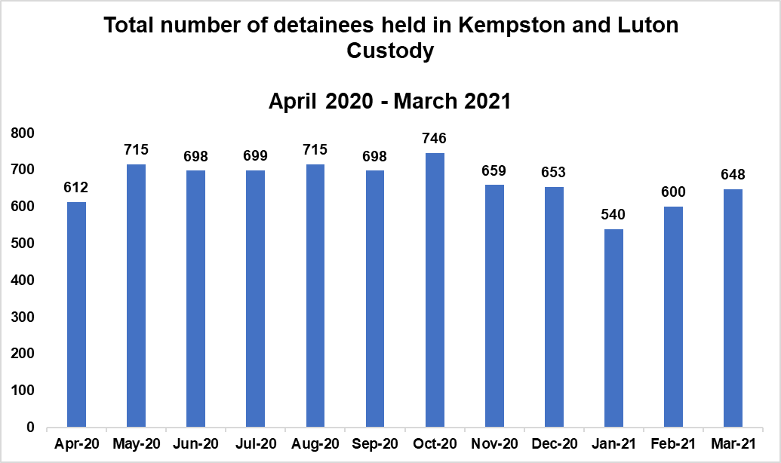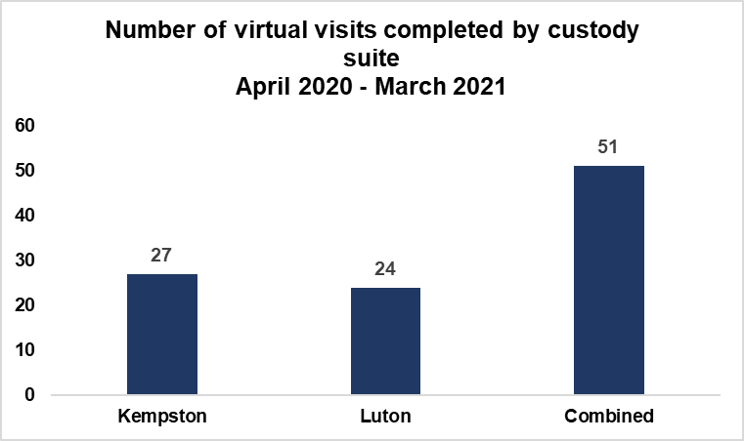
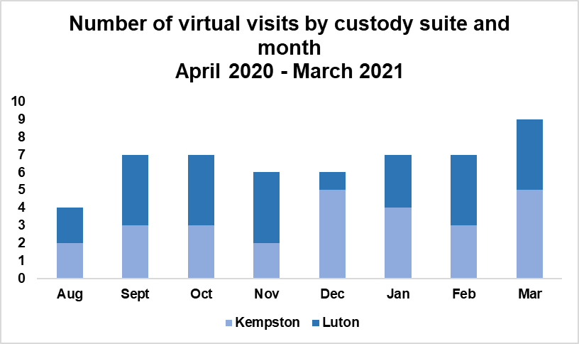

Our Volunteers

The Bedfordshire ICV scheme has a total of 24 volunteer Independent Custody Visitors (ICVs) who were appointed from the community and kindly dedicate their time to provide an essential service of checking on the health and welfare of detainees held in police custody. ICVs are unpaid volunteers who provide reassurance to the community that people who are detained in police custody are looked after appropriately and in accordance with national standards and guidance.
During a physical visit to the custody suites, a Visitor Report Form is produced by ICVs and forwarded to the OPCC with a copy being left with the Custody Inspectors at the Custody Suite. As the scheme is currently operating virtually due to the Covid-19 pandemic, ICVs are visiting detainees virtually via Microsoft Teams whereby the detainee is connected to the call via a cordless phone.
This has enabled ICVs to continue to provide a crucial service of speaking to detainees about any concerns or issues whilst in detention. Visitor Report Forms are then sent by the ICVs electronically to the Scheme Managers within the OPCC so that any issues and concerns can be addressed accordingly.
During a physical visit to custody, concerns raised by ICVs are reported to the Custody Sergeant at the time of the visit and to the Scheme Managers in the OPCC who brings them to the attention of the Custody Chief Inspector immediately. The ICVs will also have a chance to raise general concerns and matters arising from visits during the quarterly panel meetings.
During virtual visits, any concerns are raised to the Scheme Managers at the end of the call. Depending on the severity of the concerns, these are addressed with the Custody Chief Inspector immediately or within the weekly virtual meeting conducted with both the Scheme Managers and Custody Chief Inspector.
In addition, the National ICVA Conference took place virtually on the 25th November 2020 and the Regional ICVA Conference has been pushed back with an unscheduled date at present within 2021/22 due to the pandemic.
Over the last year and throughout the Covid-19 pandemic where the scheme has been operating virtually, ICVs have made a tremendous impact on key changes within custody and on behalf of the detainees. A number of issues have been raised by ICVs within the scheme such as a shortage of blankets within the cold winter months in one of the suites. This led to the ICVs, the Force and the OPCC working together proactively to ensure that blankets were delivered from the other suite immediately.
Another issue raised by ICVs was around ensuring that custody staff have a full insight of awareness into detainees who are observing Ramadan within custody. ICVs were able to discuss this concern immediately with the Inspector via the virtual call and protocol and procedure was sent from the Inspector to custody staff across Bedfordshire soon after to increase awareness and remind custody staff of procedure regarding detainees who are fasting and observing Ramadan.
As well as this, Operation Gorse has ensured that vulnerability work is being completed by the Force to safeguard detainees and ensure that appropriate adults are provided.
ICVs are able to bring knowledge from their professions and life experiences, as well as their training, to challenge standards and processes in custody and help improve matters for all within the custody environment.

Statement from Bedfordshire’s Lead ICV
The Bedfordshire Independent Custody Visitor Scheme is well established and gives the Police and Crime Commissioner, PCC, Chief Constable and the public confidence that persons detained in custody are treated according to the law, with fairness, dignity and respect.
ICVs are volunteers from the Bedfordshire community and completely independent of the Police and the criminal justice system. ICVs, in pairs, visit the two custody suites in Bedfordshire, Kempston and Luton, unannounced. The agreement between the PCC and the Chief Constable is that ICVs visit each custody suite four times per month, sufficient for ICVs to gain information but not be overbearing on the operation of custody. At present, there are 24 ICVs on the scheme.
In early March 2020, with the onset of the first wave of the pandemic, the CEO of OPCC decided on the grounds of ICV safety, to stop visits to custody suites. The first wave of the pandemic led to an extended national lockdown with much public anxiety due to the lack of knowledge of this previously unknown virus. The CEO kept the ICV visits under review and identified an alternative method of ICVs fulfilling their role. As a result, in August 2020, ICVs started to carry out virtual visits from the comfort of their homes.
This temporary process was initially for ICVs to have a general discussion with a detention officer or custody sergeant on: whether rights and entitlements are being met; appropriate adults are provided where necessary; legal advice is made available where requested; cleanliness and hygiene standards are met with sufficient personal protective equipment; hygiene of detained persons; provision of blankets, replacement clothing as well as hot food and sandwiches; functionality of CCTV; availability and storage of religious material and reading material which are quarantined for 72 hours following use; outstanding maintenance issues.
Additionally, the custody situation of up to 5 detained persons are considered, including: any injuries on arrival and, if so, whether these were received in the course of the arrest; medical condition, both physical and mental; whether the health care professional has reviewed the detainee; the offering of food and beverage, accepted or declined, and recorded in the custody record.
This temporary process developed further in October 2020 with the advent of a telephone with a mobile handset, provided by the OPCC, at each custody suite. After receiving an update from the detention officer or custody sergeant, this phone is taken to the cell and the detainee is invited to talk with the ICVs. The discussion includes the general welfare of the detainee: knows why detained; received rights on arrival in custody; requested legal advice or not; detention known to family or friends; carer for animal, child or elderly relative; medical attention or medication requirements. Welfare is discussed with each detainee including: food and beverage; dietary needs, religious needs; replacement clothing; offering of hygiene products for females; the cell temperature; overall treatment whilst in custody. The cell accommodation is discussed with detainees in relation to: cleanliness; bedding; washing and shower facilities; functional ablution facilities; adequate lighting; functional call bell. Finally, detainees are asked whether the ICVs could review their custody record to check on process only. Any observations are taken to the detention officer or custody sergeant accompanying ICVs on their visit for resolution.
Not all ICVs have been able to assist with virtual visits as they do not have access to the technology for a call on ‘Teams’. This has resulted in other team members, with access, making additional calls. This ensures that a weekly call is made to each Custody suite.
The OPCC has had a successful recruitment campaign for new ICVs. They have received their basic training and then sat in as observers to listen to how virtual visits are managed by more experienced colleagues. The next stage has been for the new ICVs to take part in a mock virtual visit prior to playing an active role in a virtual visit with other ICVs. This programme has worked well and prepared new ICVs to adapt quickly to the virtual visits.
This is the best that ICVs can do remotely until such time as ICVs are able to physically visit once again. This is currently under review by the OPCC taking account of the government’s ‘earliest dates’ for the relaxation of restrictions, local infection rates, severity of infections and transmissibility.
Stephen O’Connor, Lead Independent Custody Visitor

ICV Statistics for Bedfordshire – 2020/21

Bedfordshire’s ICV Scheme seeks to be representative of the local community, including ethnicity, gender and age – please see diversity data information below. (There have been no disabilities declared by ICVs)
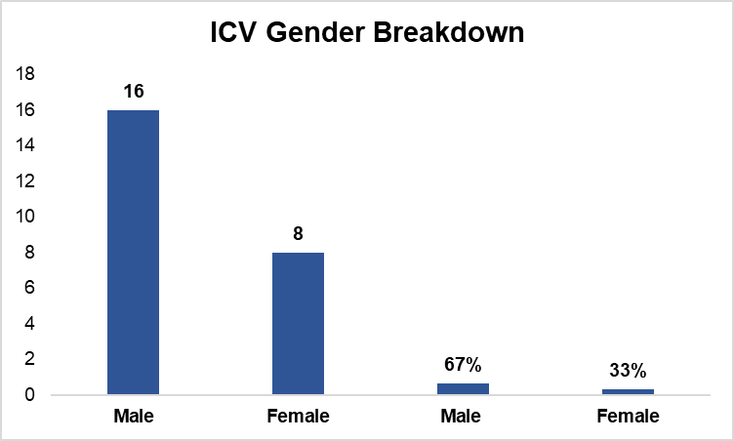
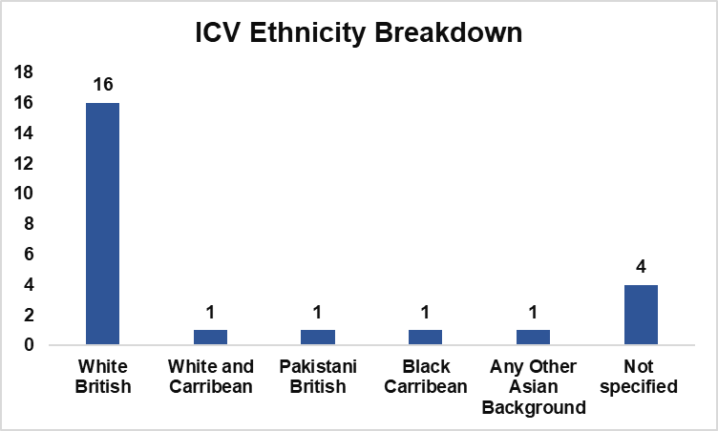
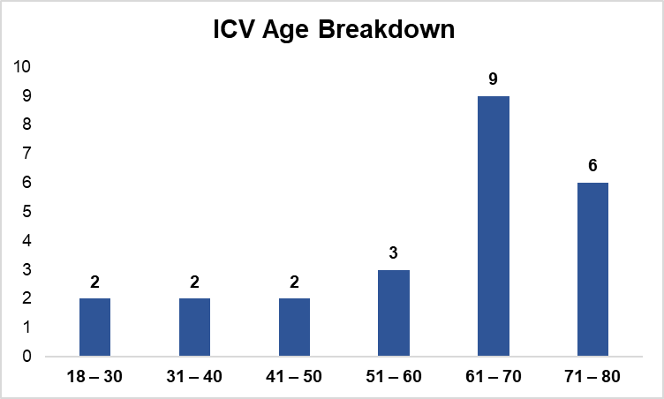
Bedfordshire’s ICV scheme are currently in the process of a recruitment campaign and have been in contact with a number of local universities and colleges within the area to increase the dynamic of variety of ages of ICVs within the scheme.
Independent Custody Visitors must be aged over 18, reside in Bedfordshire and be a resident in the UK for at least three years prior to the date of application. No specific qualifications are required as full training and support is provided, however visitors should be good listeners, non-judgmental and unbiased.

Comments about Custody Staff

Overall, ICVs rated the professionalism and helpfulness of custody staff very highly. ICVs reported on a couple of minor occasions where custody staff joined the virtual calls late however this is to be expected on occasions where staffing is short and the suites are busy. This was addressed within the weekly calls held with the Scheme Managers and Chief Inspector/Inspectors who have been very helpful in supporting the ICVs and scheme.

Within the most recent HMICFRS inspection it was raised that the logging of food and beverage within detainee custody records was not being documented accurately within the Bedfordshire custody suites. This has been closely monitored by the ICVs within their reports and any inaccuracies reported have been highlighted to the Chief Inspector.

Comments and Concerns of Detainees

ICVs reported that a significant number of detainees had commented positively on their treatment and care within Bedfordshire Police Custody.

Diversity Data Recording of Detainees

Diversity data of detainees is collected and monitored to ensure that any matters of concern or trends relating to protected characteristics of detainees identified during the custody visiting process are able to be addressed.

The data categories recorded are gender, whether the detainee is an adult or juvenile and their ethnicity, as defined by the detainee and detention category. This data is inputted on the detainee custody record, provided by custody staff to ICVs and is then transferred to the custody visiting report. Disability is not recorded but this is picked up in the dignity and risk assessment carried out as each detainee is booked into custody. ICVs would be informed of this if appropriate.

Throughout the Covid-19 pandemic and whilst operating the scheme virtually, ICVs have been unable to speak to detainees who do not speak English. This is due to the visits not being completed face to face and therefore flashcards have not been used. The usual practice when operating visits face to face is for the detainees to read information provided within their own language and to communicate via the use of flashcards.

Panel Meetings

All ICVs are invited to attend quarterly panel meetings where matters discussed include an update from the Police and Crime Commissioner's office, updates from Bedfordshire Police Custody, performance monitoring of the scheme and national and regional update information. Panel meetings are chaired by the OPCC and are attended by the Chief Inspector of Custody and one or two Custody Inspectors who provide reports to ICVs and keep them up to date with activity within custody.

Panel meetings have been held virtually since March 2020 with attendance from ICVs, the Chief Inspector, Inspectors and the OPCC. ICVs have found that Panel meetings held on a quarterly basis are very useful to allow engagement with custody and to have the opportunity to ask any questions and be provided with up to date information. Panel meetings are also used to provide ICVs with training and guidance. Regular communication is provided from the OPCC to ICVs as well as the quarterly Panel meetings to ensure that they are engaged with the scheme and feel supported within their role. We hope to commence face to face Panel meetings by the end of the year and in line with National Guidance.

Kempston Custody Suite Build

Bedfordshire Police are in the process of a new custody suite being built at Kempston Headquarters which is estimated to be opened within February 2022. The Chief Inspector and Inspectors value the ICVs input and for them to be involved and engaged with the process. Project meetings for the build are being held on a frequent basis and a date is currently being arranged by the Chief Inspector for ICVs to attend a virtual meeting of a walkthrough of the new custody build.

Regional and National Independent Custody Visiting Association

Bedfordshire Independent Custody Visiting Scheme sits within the Eastern Region with Cambridgeshire, Essex, Hertfordshire, Norfolk and Suffolk. The six Scheme Managers meet quarterly to discuss their experiences and share best practice.

The Bedfordshire Scheme Manager is the appointed Eastern Regional Lead and continues to work with ICVA. She is a member of the ICVA board and the National Expert Forum (NEF).

ICV Recruitment

We are recruiting for new ICVs!

We are currently recruiting for ICVs to join our scheme and are working on promoting the awareness of the scheme to the public via our social media platforms.

If you would like to become an ICV within Bedfordshire or would like to find out further information about the scheme, contact details for the OPCC are below:

Email: PCC@bedfordshire.pnn.police.uk
Tel: 01234 842064

Conclusion

Bedfordshire Independent Custody Visitors are committed and dedicated to their role and make a huge impact on detainees’ experience within custody which is evidenced throughout this report. They work hard to reach agreed targets and go the extra mile to provide an outstanding service for detainees visited, custody staff and the OPCC.

- detainees in Bedfordshire Police Custody are treated fairly and in accordance with the Police and Criminal Evidence Act 1984 (PACE) and associated codes of practice;

- the conditions detainees are kept in are clean and safe and any matters of concern are recorded and dealt with effectively, and;

- the rights and entitlements of detainees in Bedfordshire Police Custody are observed and adhered to.

The election of Police and Crime Commissioners (PCC) is taking place on Thursday 6th May which will result in a new Police and Crime Commissioner for Bedfordshire. A full induction will be presented to the newly elected PCC in May and the importance of the scheme will be addressed.

The Bedfordshire Independent Custody Visiting Scheme is the Police and Crime Commissioners statutory duty in holding the Force to account and is used as a means of being an advocate for the voice of the public. This is an example of how members of the community can become involved in policing to really make a difference and be able to promote confidence and reassurance in policing in Bedfordshire.

** END OF REPORT **

