

**Independent Custody Visiting**

Annual Report

21/22

**Contents**

Introductions | Pages 3 - 4

Background of the scheme | Page 5

The Custody Estate | Page 6

The Bedfordshire Scheme | Pages 7 - 8

Detained Persons & Visits Statistics| Pages 9 – 10

The Covid-19 Pandemic | Page 11

Equality and diversity | Pages 12 - 13

Detainees and the Terrorism Act | Page 14

Feedback from visits and ICVs| Pages 15 - 17

Independent Custody Visiting Association | Page 18

Who are the NPM and what is OPCAT? | Page 19

How to become an ICV | Page 20

# Introduction

Festus Akinbusoye

Police and Crime Commissioner for Bedfordshire

**Firstly, I would like to hugely commend the custody staff and our volunteers in Bedfordshire for their dedication and flexibility in ensuring the continuity of this vital scrutiny function throughout the Covid-19 pandemic and beyond.**

**Independent Custody Visiting is an essential element of the work of the PCC’s office, striving to ensure that Bedfordshire Police are open and accountable to the people they serve and where Kempston and Luton Custody Suites are scrutinised to ensure the safe and lawful detention of people.**

**Our Independent Custody Visitors go the extra mile in dedicating and volunteering their time to check on not only the treatment and welfare of people detained in Bedfordshire Police Custody Suites, but also the welfare of the Custody Staff and the cleanliness and safety of the estate, treating each person with dignity and respect throughout.**

**Independent Custody Visiting gives the public a real insight into the conditions in custody and provides reassurance that someone independent of Bedfordshire Police has regular oversight. Independent Custody Visitors emphasise that they do not want or need to know why the detained person is there but ask about their welfare, if they have been treated according to the law for their rights and entitlements and much more.**

**I immensely thank our Independent Custody Visitors for their continued dedication, and I am very grateful to each and every volunteer for providing such a crucial role in increasing the public’s trust and confidence in Bedfordshire Police, contributing to a safer Bedfordshire.**

# Introduction

Michelle Welsh

Detective Chief Inspector Lead for Performance, Bail and Policy for Bedfordshire and Hertfordshire Constabularies and Head of Custody for Bedfordshire

I have been the lead for Custody Since February 2021 following 18 plus years as an investigator in public protection, with safeguarding and vulnerability at the forefront of my mind. I am extremely proud to be working within this team. My policing experience holds me in good stead when considering the vulnerabilities of those who come into police custody.

Bedfordshire has two custody suites, one in the south of the county at Luton Police Station and the other in Kempston, which is a brand new Police Investigation Centre (PIC), which opened in April 2022. The build project was not without its challenges due to the demands of COVID material shortages, design modifications and some weather challenges. Despite this, the PIC opened on time and within budget. This was thanks to the professionalism and dedication of all those involved including contractors, staff, and the project teams.

The PIC has excellent facilities for the investigation teams with the public protection teams all housed on the one floor, enabling improved collaborative working and information sharing, which supports the investigation process, the victims, and communities we serve. The Custody Suite is an excellent facility, it is light and airy with a calm atmosphere. The project team and custody leaders are also working on internal decoration to aid those with neurodiverse needs and to calm those that may be anxious whilst in custody. We are proud of the murals within the exercise yard (a beach and sports scene football goal for DPs to kick a foam ball at).

To ensure the teams and DPs at Luton are further supported, we are considering improvements for this suite also, including the inclusion of a mural. I am looking to improve the journey through custody and beyond for those that are detained, to support them and identify any unknown safeguarding or non-recent investigation needs. The support and the scrutiny of Independent Custody Visitors is invaluable and provides us with a positive critical eye. They are supportive of the custody teams whilst addressing any challenges that they see; it is a good partnership. I believe the ICVs have a significant role to play in improving the custody journey and beyond as they are an independent point of contact between the detained person and the custody teams. I would personally like to thank them for their honest feedback and for all the work they do to support the DPs and the criminal justice process.

# Background

Originally referred to as Lay Visiting, Independent Custody Visiting is a system that has been developed to meet one of the recommendations from The Scarman Report. The Scarman Report was produced as a result of the Civil Disorders in 1981 where several outbreaks of unrest occurred in major cities throughout the country. The most significant of these disorders took place in Brixton when hundreds of young people attacked property and the police.

The cause of these disorders centred around people protesting about oppressive policing and in particular the alleged harassment of people, especially young black people, by the police. These incidents were anti-police and voiced a lack of trust in the law and order authorities.

After days of unrest, these serious incidents led to the government ordering an urgent inquiry and appointing Lord Scarman to conduct a comprehensive investigation into the events.

Lord Scarman recommended that provision be made for random checks by people other than police officers on the interrogation and detention of suspects in police stations. The aim of this was to promote public confidence in policing, ensuring all policing activity was accessible and transparent to scrutiny by the public.

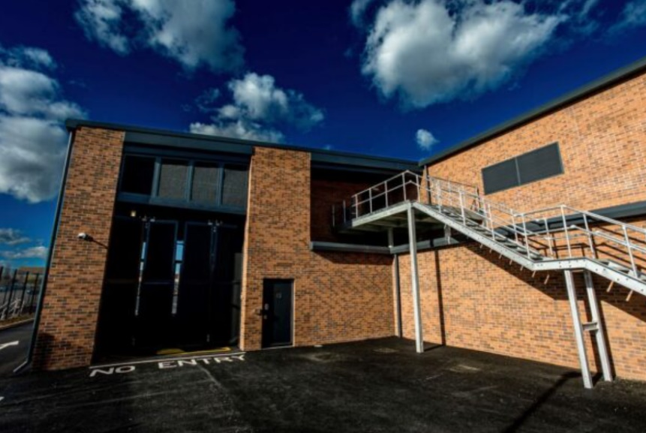The Police and Crime Act 2002 made custody visiting statutory with the Home Office introducing the ‘Codes of Practice for Independent Custody Visiting’. The Police Reform and Social Responsibility Act 2011 introduced Police and Crime Commissioners and gave them the responsibility for operating and overseeing the scheme in their police area.

# The Custody Estate

Bedfordshire has two custody suites which are located in Luton and Kempston. Luton Custody Suite holds 21 cells, and the newly implemented Kempston Custody Suite holds 22 cells.

The new state-of-the-art Bedfordshire Police Custody Suite located in Kempston is the first major building commissioned on site since 2005 and also includes 1,600sqm of new office space for Police Officers and Staff. This allows the force to have all of its investigation teams operating under one roof, which translates into benefits around operational work and information sharing. Work began on site in August 2020 and the suite officially opened in April 2022.

**Chief Constable for Bedfordshire Police, Garry Forsyth,** said:

*“This is an amazing investment for the force and a positive change for Bedfordshire Police.*

*“New technology and innovative design will help us give the maximum care and support for those visiting custody, as we continue to improve the service we give.*

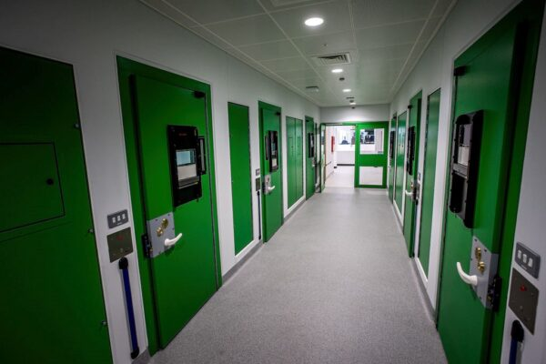*“As well as the new custody suite, the new working space for officers and staff will create an innovative and cohesive way of working.*

*“The building will benefit the force for many years to come and marks a key piece of history for the force.”*

Once booked in, detainees are placed in either the blue or green wing. Each wing has specialised cells for those deemed vulnerable, children or first time arrested. These cells come with an increased viewing screen within the door. There are seven interview rooms – two with moveable furniture, four consultation rooms and two virtual courts.

# The Bedfordshire Scheme

An Independent Custody Visitor (ICV) is a volunteer who visits Police Custody Suites to check on the welfare of those who have been detained. This can include but is not limited to checking that a detainee has received their rights and that they have access to free legal advice, entitlement to food and beverage and that they are being treated fairly.

The Bedfordshire Scheme currently has 30 ICVs volunteering across both Custody Suites as of the beginning of June 2022. ICVs attend four quarterly panel meetings a year and receive regular training in Bedfordshire. The Chief Inspector of Custody attends the quarterly panel meetings to provide an update and to allow the volunteers to ask any questions. ICVs always visit in pairs and as well as checking on the welfare of detainees, they also inspect the cells and facilities within the custody suite for health and safety purposes.

ICVs can also inspect custody records where appropriate and if consent has been obtained from the detainee. If an ICV discovers an issue on their visit, this is raised to the Custody Sergeant present or the Custody Inspector if the matter is of a serious nature that requires urgent attention.

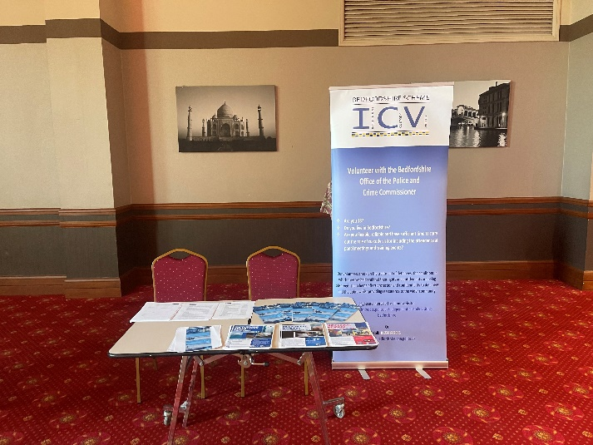Once ICVs write up their report and complete the visit, the paperwork is sent by Custody to the Office of the Police and Crime Commissioner (OPCC) ICV Scheme Administrator who collates the information and reviews any issues reported. ICVs visit custody suites unannounced and at any time or day of the week and are completely independent from Bedfordshire Police Force. Throughout the 21/22 period, the number of ICVs within the Bedfordshire scheme has increased due to a successful recruitment campaign. ICVs have assisted the OPCC in recruitment and a recruitment steering group was implemented to share ideas on how the scheme can actively recruit to represent the community of Bedfordshire through increasing equality and diversity.

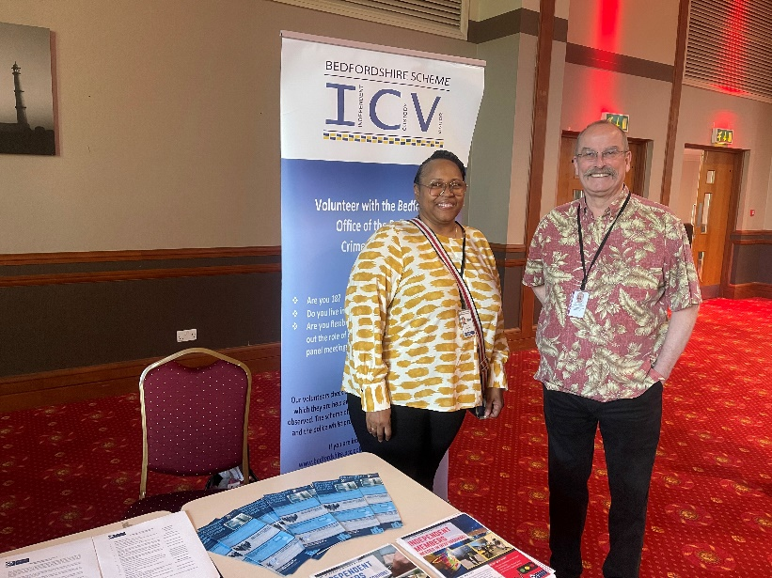This involved contacting faith groups, designing a new recruitment poster, contacting local volunteer centres, and updating the ICV page on the OPCC website. The ICV scheme also had its own stand at the Multi-Faith Conference event which was held by the OPCC to increase awareness of the scheme and reach Bedfordshire communities. At present, there are 7 ICVs who were successful at interview and are currently undergoing vetting with further interviews booked in over the upcoming months.

Recently, Festus Akinbusoye, Police and Crime Commissioner for Bedfordshire, shadowed an ICV visit with two Bedfordshire ICVs at the new Kempston Custody Suite. The Police and Crime Commissioner found it reassuring to see that everything was in order and as it should be, and that no issues were identified by the ICVs.

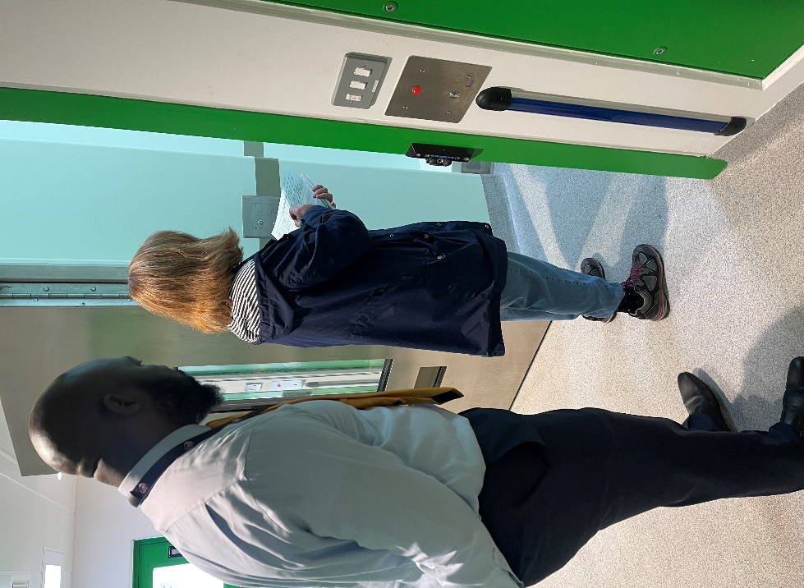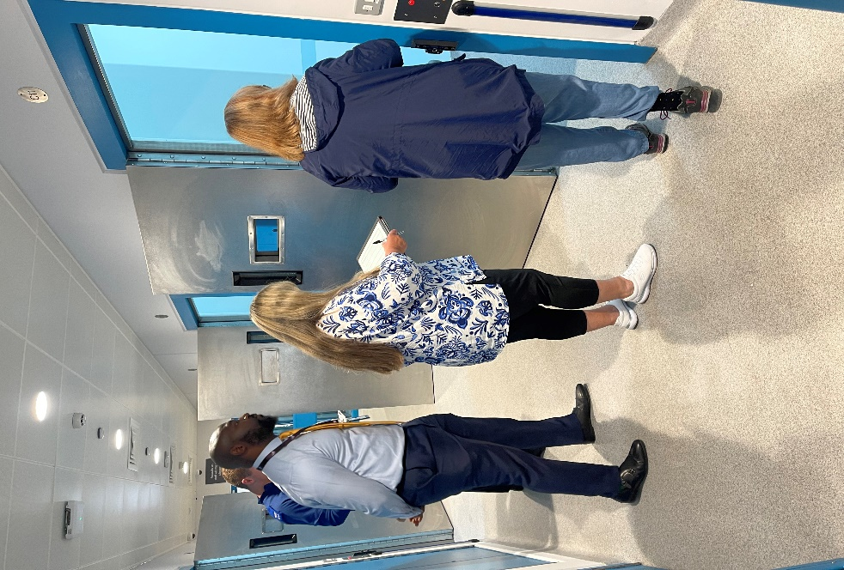

# The Bedfordshire Scheme - Detained Persons Statistics

**Number of Detained Persons in Bedfordshire Police Custody**

**1st April 2021 to 31st March 2022**

|  |  |  |  |
| --- | --- | --- | --- |
|  | Kempston | Luton | Total |
| March 2022 | 294 | 428 | 722 |
| February 2022 | 291 | 392 | 683 |
| January 2022 | 301 | 432 | 733 |
| December 2021 | 296 | 386 | 682 |
| November 2021 | 320 | 426 | 746 |
| October 2021 | 360 | 483 | 843 |
| September 2021 | 301 | 417 | 718 |
| August 2021 | 350 | 407 | 757 |
| July 2021 | 328 | 458 | 786 |
| June 2021 | 306 | 432 | 738 |
| May 2021 | 268 | 365 | 633 |
| April 2021 | 262 | 353 | 615 |

Total number of Detained Persons 1st Apr 21 – 31st Mar 22 = 8656

Number of visits conducted by ICVs in Bedfordshire Police Custody

**1st April 2021 to 31st March 2022**

|  |  |  |  |
| --- | --- | --- | --- |
|  | Kempston | Luton | Total |
| March 2022 | 5 | 4 | 9 |
| February 2022 | 5 | 5 | 10 |
| January 2022 | 3 | 3 | 6 |
| December 2021 | 3 | 1 | 4 |
| November 2021 | 5 | 3 | 8 |
| October 2021 | 3 | 4 | 7 |
| September 2021 | 5 | 2 | 7 |
| August 2021 | 4 | 3 | 7 |
| July 2021(Virtual/Physical) | 3 | 2 | 5 |
| June 2021(Virtual) | 5 | 6 | 11 |
| May 2021 (Virtual) | 4 | 4 | 8 |
| April 2021 (Virtual) | 5 | 6 | 11 |

Total number of ICV visits 1st Apr 21 – 31st Mar 22 = 93

***Please note that physical in-person visiting resumed from July 2021. The data recorded prior to July 2021 involved ‘virtual’ visits whereby ICVs spoke to Detained Persons and Custody via Microsoft Teams due to the Covid-19 pandemic and lockdown.***

# The Bedfordshire Scheme - Detained Persons Statistics (cont.)

Number of Detained Persons visited by ICVs

**1st April 2021 to 31st March 2022**

|  |  |
| --- | --- |
| Quarter | Number of DPs Visited by ICVs |
| Quarter 4 (Jan 22 – March 22) | 117 |
| Quarter 3 (Oct 21 – Dec 21) | 90 |
| Quarter 2 (July 21 – Sept 21) | 79 |
| Quarter 1 (April 21 – June 21) | 60 |
| Total = | 346 |

Days of the week of ICV Visits

**July 2021 - March 2022**

**This data has been collated from July 2021 when physical visiting recommenced and gives an up to date reflection on which days of the week that visits are being conducted. As the scheme actively recruits more volunteers, we anticipate that visits will be more frequent on Fridays, Saturdays, and Sundays.**

# The Covid-19 Pandemic

The Covid-19 pandemic changed the way that the world works, police custody was no different to this. Whilst much of life had shut down and paused during the lockdown; policing did not. With custody continuing to operate, knowing that police would be under unprecedented demands and knowing that vulnerable detainees were likely to be held there, monitoring became increasingly important. Human rights, dignity and wellbeing come under pressure in a crisis.

Independent Custody Visiting continued within Bedfordshire with visits being conducted via Microsoft Teams, with ICVs speaking to detainees via audio. This allowed the scheme to monitor and report on problems, continuing to provide an independent voice locally and nationally. This was essential and the OPCC are tremendously thankful to our volunteers for continuing this at a time of great difficulty.

Physical visiting resumed in July 2021 with a strict procedure in place as the detainees, ICVs and Custody Staffs health and safety is paramount. This included ICVs wearing face coverings, social distancing and wearing aprons and goggles if requested. ICVs were given the option of returning to physical visiting and the Scheme Managers ensured that if ICVs were not to feel comfortable about returning then their choice would be supported. All ICV Panel meetings and training sessions were held virtually on Microsoft Teams.

All ICVs have now returned to physical visiting with the rules within the procedure being relaxed and the Police and Crime Commissioner and his Office are hugely grateful for the ICVs continued support.

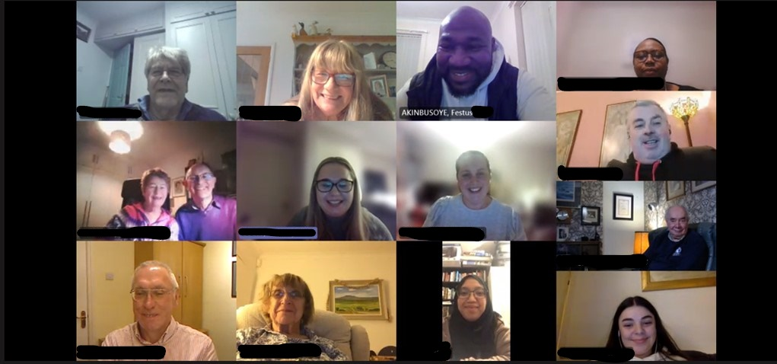

*Police and Crime Commissioner with ICVs at a virtual Panel Session*

# Equality and diversity

Bedfordshire OPCC’s Independent Custody Visiting Scheme is firmly committed to promoting equality of opportunity for all local people and communities and are committed to recruiting ICVs who are representative of the community, considering the different ethnic origins, gender, and age variety.

We welcome any suggestions as to how we can further improve our uptake of volunteers from all walks of life and areas within the community.

Below you can find further details on the equality and diversity of our ICVs in the Bedfordshire scheme.

Data recorded from the 2011 census across Bedford Borough, Central Bedfordshire and Luton is shown below.

Please note that the statistics for each borough have been recorded differently.

|  |  |  |  |  |
| --- | --- | --- | --- | --- |
| Ethnicity | Luton | Bedford Borough | Central Bedfordshire | ICV Ethnicity Bedfordshire |
| White British | 54.66% | 80.55% | 89.7% | 87% |
| Mixed | 4.08% | 3.42% | 1.47% | 0% |
| Asian | 30% | 11.39% | 2.6% | 3% |
| Black | 9.80% | 3.94% | 1.4% | 10% |
| Other | Not recorded | 0.7% | 4.2% | 0% |

(Data of ICV Ethnicity in Bedfordshire from charts/graph as of the beginning of June 2022)

# Equality and diversity (cont.)

An equality and diversity statement can be found on the OPCC website under the ICV section detailing our commitment towards reflecting the population of Bedfordshire accurately throughout our scheme.

The data below has been collected as of the beginning of June 2022.

**Age Breakdown**

|  |  |
| --- | --- |
| Age | Number of ICVs |
| 18 - 34 years | 3 |
| 35 - 49 years | 1 |
| 50 - 64 years | 8 |
| 65-74 years | 11 |
| 75-84 years | 6 |
| 85 and over | 1 |

Gender Breakdown

|  |  |
| --- | --- |
| Gender | Number of ICVs |
| Male | 15 |
| Female | 15 |
| Other | 0 |
| Not Reported | 0 |

# Detainees and the Terrorism Act

Anyone arrested under the Terrorism Act (TACT) may be detained for up to 14 days. TACT visits tend to be arranged (although can be unannounced); as there are relatively few detainees and ad hoc visitors are unlikely to find detainees. Constabularies contact Scheme Managers as soon as practicable after someone comes into TACT detention and ICVs arrange to visit.

ICVs themselves are specially selected to perform this role. They have additional security clearance and attend additional specialist training. We have one ICV in Bedfordshire who are trained as TACT ICVs and they are on a rota with colleagues to provide cover for the whole of the Eastern region.

They have an additional duty to act as the eyes and ears of the Independent Reviewer of Terrorism Legislation (IRTL) and will send a report to them following their visit.

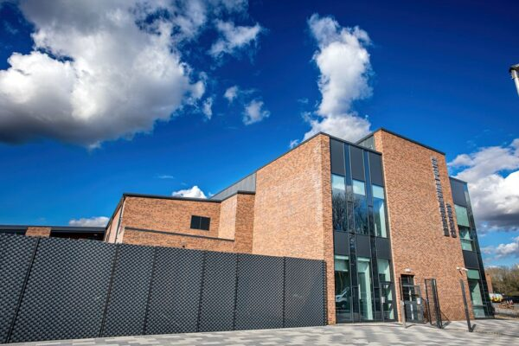

# Feedback from ICVs and visits

ICVs play a huge part in implementing change for detainees, custody staff and the wider community and provide reassurance to the OPCC, Bedfordshire Police and residents within Bedfordshire. ICVs will always try to determine if a detainee is happy with the treatment received whilst in Custody and this is then fed back to the OPCC. Bedfordshire Police are updated where there are any adverse comments as well as any positive comments, which are just as important.

Throughout 21/22 and due to the ICVs tremendous work, several changes were implemented.

* Several ICVs notified the OPCC of a shortage of blankets for detainees within custody. The issue was raised to the Chief Inspector who escalated the matter and addressed this promptly.
* ICVs visited the new Kempston custody suite on several occasions whilst it was being built and provided feedback, such as signage to be placed throughout the suite for fire and escape exits and arrows on the ceiling of cells pointing to Mecca for Muslim detainees who would like to pray.
* ICVs reported concerns surrounding detainees who were observing Ramadan whilst in Custody. This was escalated to the Inspector who sent guidance to all Custody Staff on the process for detainees who are observing Ramadan and fasting. A Ramadan timetable was also sent to all Custody Staff and ICVs.
* ICVs reported on one occasion that there was out of date ready meals. This was rectified immediately by Custody staff. ICVs check stock levels and dates of meals and sandwiches throughout their visits as part of the health and safety review of the premise.

Comments from ICVs that are noted throughout report forms and of high importance are that Custody Staff are friendly, very helpful and approachable when conducting visits.

# Feedback from ICVs and visits (cont.)

ICVs worked proactively and positively with the Chief Inspector, Inspectors and Project Manager to make recommendations and suggestions whilst building works were underway for the new Kempston Custody Build. ICVs were also invited to the ‘Topping Out Ceremony’ of the Custody Build.

# Account from Lead ICV

*“The Bedfordshire ICV Scheme operates within the well-established national system whereby trained and vetted volunteers attend police custody suites unannounced, to check on the treatment and welfare of detainees, the fulfilment of their rights and entitlements as well as the conditions in which they are held. ICVs are a critical friend to the Police and the scheme is one of the statutory obligations of the Police and Crime Commissioner.*

*The Bedfordshire ICV scheme continues to function well, with the help of approximately 30 volunteers and the scheme managers from the Office of the Police and Crime Commissioner.*

*A small group of ICVs and a scheme manager banded together this year to produce a recruitment campaign which successfully increased our numbers. Once new ICVs have been interviewed, vetted, and accepted, initial training takes place over a day. This is led by one of the scheme managers with interjections from one or two ICVs recounting some of their experiences. The final session has the new ICVs in scenarios with ‘actor’ detainees and checking on their welfare. New ICVs have also had a visit around one of our custody suites.*

*Bedfordshire was well represented at the national meeting of the ICV Association in April and attendees were treated to several extremely good presentations. The talks on racism were the highlights of the day for me.*

*Two ICVs and a scheme manager attended the Police and Crime Commissioner’s multi-faith evening event and engaged not only with the PCC but also with the many other groups of volunteers, thereby increasing our exposure.*

*All ICVs who have visited the newly commissioned, spacious, state of the art custody suite at Kempston have been extremely impressed. The suite is functioning extremely well. Benefits for detainees include two outdoor exercise areas. There are also benefits for custody staff who have natural daylight in the booking-in and charging area.*

*We continue to have quarterly meetings for ICVs where we receive updates from the Police as well as refresher training.”*

* Stephen O’Connor, Lead ICV

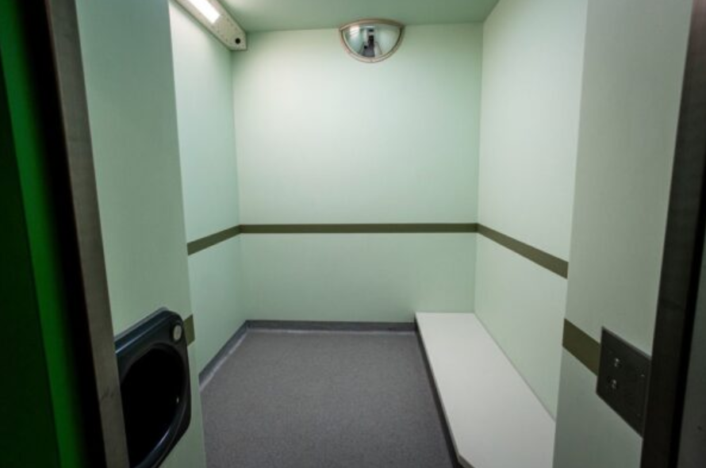

*Custody Cell in Kempston Custody Suite*

# Independent Custody Visiting Association (ICVA)

The Independent Custody Visitors Association (“ICVA”) is a Home Office, Policing Authority and Police and Crime Commissioner (PCC) funded membership organisation set up to lead, support and represent PCC and Policing Authority led schemes.

ICVA work closely with the Government and Criminal Justice organisations to:

* Promote and support the effective provision of independent custody visiting in police forces in the United Kingdom
* To support independent custody visitors across England and Wales in contributing, wherever possible and appropriate, initiatives to improve conditions in police custody.
* Ensure alignment between the local delivery of independent custody visiting and the UK’s obligations under relevant international treaties, including the Optional Protocol to the Convention Against Torture (OPCAT) and European Human Rights legislation.

ICVA are members of the UK National Preventive Mechanism (UKNPM) as required by the Optional Protocol against Torture and other Cruel, Inhuman or Degrading Treatment or Punishment (OPCAT) – an international human rights treaty designed to strengthen the protection of people deprived of their liberty.

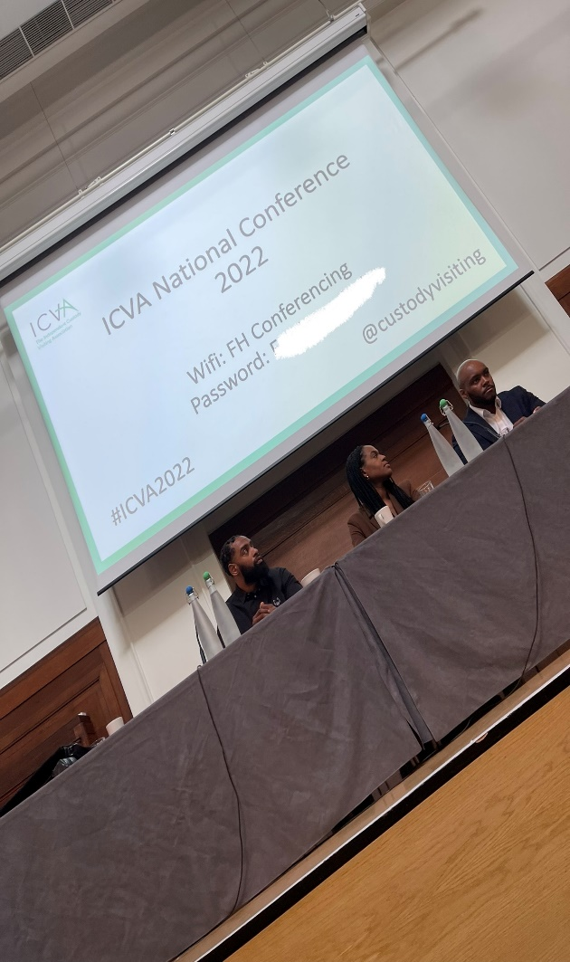Several ICVs attended the ICVA National Conference 2022 and found this a very engaging and useful session, listening to guest speakers and taking part in group activities with other schemes across the country.

For more information regarding the work of the Independent Custody Visiting Association (ICVA) please visit their website:

[www.icva.org.uk](http://www.icva.org.uk)

or on Twitter:

@CustodyVisiting or @projectICVA

# Who are the NPM and what is OPCAT?

The UK National Preventive Mechanism was established in 2009 to strengthen the protection of people in detention through independent monitoring.

In coordination across the four nations of the UK, the NPM focuses attention on practices in detention that could amount to ill-treatment and works to ensure its own approaches are consistent with international standards for independent detention monitoring. You can find out more about the NPM and its members [here.](https://www.nationalpreventivemechanism.org.uk/)

The Optional Protocol to the Convention against Torture and Other Cruel, Inhuman or Degrading Treatment or Punishment (OPCAT) is an international human rights treaty designed to strengthen the protection of people deprived of their liberty.

Its adoption by the United Nations General Assembly in 2002 reflected a consensus among the international community that people deprived of their liberty are particularly vulnerable to ill-treatment and that greater efforts were needed to prevent such ill-treatment from happening. OPCAT entered into force in June 2006.

# How to become an Independent Custody Visitor

The purpose of Independent Custody Visiting is to provide assurance that detainees in Bedfordshire Police Custody are:

1. Treated fairly and in accordance with the Police and Criminal Evidence Act 1984 (PACE) and associated codes of practice

2. That the conditions detainees are kept in are clean and safe and any matters of concern are recorded and dealt with effectively.

3. That the rights and entitlements of detainees in Bedfordshire Police Custody are observed and adhered to.

ICVs come from all sections of the community. They must be aged over 18, reside in Bedfordshire and be a resident in the UK for at least three years prior to the date of application. No specific qualifications are required as full training and support is provided; however, visitors should be good listeners, non-judgmental and unbiased.

There are some restrictions on who can volunteer as an ICV in order to avoid conflicts of interest. For example, serving members of the police force, appropriate adults and those who currently work for the criminal justice system are not eligible to become custody visitors. If you are concerned that you may have a conflict of interest, then please contact the Scheme Manager using the contact details below.

If you would like more information about becoming an Independent Custody Visitor in Bedfordshire, or for general information regarding the scheme, please use the contact details below.



CONTACT

**ICV Scheme Administrator**  
OPCC**,** Bedfordshire Police Headquarters  
Woburn Road  
Bedford      
MK43 9AX

 **Tel:** 01234 842066

**Email:** [PCC@beds.police.uk](mailto:PCC@bedfordshire.pnn.police.uk)

Web: <https://www.bedfordshire.pcc.police.uk/independent-custody-visiting/>